Speaking and Listening for Academic Purposes: Tutoring Jake
Sarah Sherman
APLNG 493
05/05/09
Course Development Project:

Needs Assessment
My tutee, Jake, is a native speaker of Korean. He has lived in the United States for less than one year. He is a MS graduate student majoring in Civil Engineering. He graduates next May (2010) and wants to remain in the US, eventually moving his family over. He needs to improve his English speaking and listening skills, especially in academia. In order for Jake to remain in the US, he needs financial help from either a research assistantship or a teaching assistantship. His advisor told him he couldn’t get a research assistantship if he didn’t improve his oral English by August 2009. His future depends on his proficiency and performance level, so this is a high-stakes course.
Jake has had English instruction in Korea for many years; however, his Korean classes focused on reading and writing with little to no instruction on listening and speaking English. Jake needs to develop his oral English skills for the research assistantship and American English Oral Communicative Proficiency Test (AEOCPT), but he will also need these skills for his thesis defense and for his career in the US. He will need help in English prosodic features, pronunciation, presentation skills, and techniques for asking and answering questions. He needs to develop strategies for listening and speaking so he can become more independent in his learning and asses himself.

Goals and Objectives
This course will meet twice a week for one hour through summer vacation. The overall goal of this course is to improve Jake’s speaking and listening English skills in an academic setting. Further goals are to improve presentation skills, pass the AEOCPT, successfully defend his thesis, and begin a career in the United States.
In order to achieve these goals, he will need to meet several objectives. He will study prosaic features of English and learn why, when, and how they are used. He will work on phonetics and pronunciation, such as the distinction between /b/ and /v/. He will learn and develop strategies for listening, speaking, and answering questions. In this course, he will learn how to simplify concepts for undergraduate students he would teach as an ITA or to an audience with no technical knowledge of civil engineering. He will also need to learn the expectations of being a teaching assistant, including knowledge about office hours, planning lessons, and what to expect culturally about his future students.

Conceptualized Content
This is a mind map of how I have conceptualized this course.
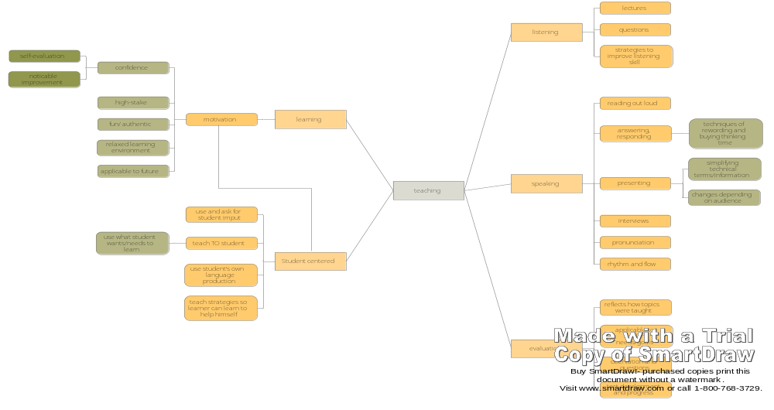
[please forgive minor trouble with software!] 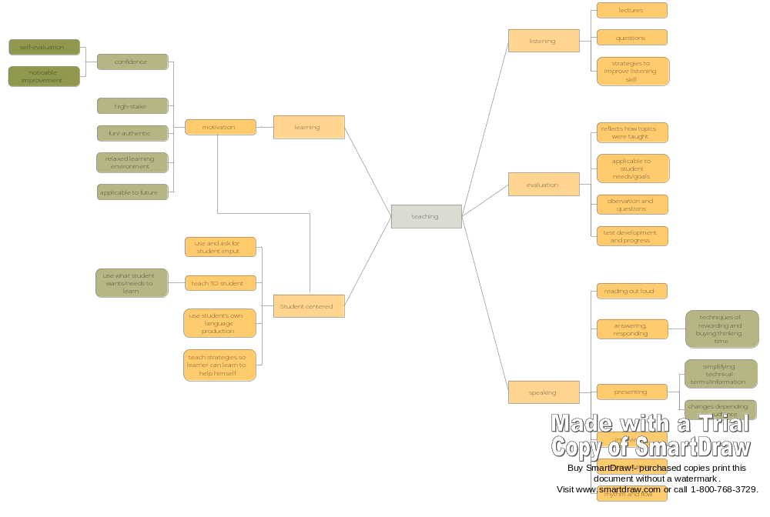

Organized Content
Jake wanted to focus the beginning of our tutoring course (prior to June) on learning and practicing prosodic features and pronunciation, training his ear, and learning strategies; working on language skills without focusing on academia. The second part of our course (beginning in June) will focus on academic language: Working with language required in his field, for teaching, for presenting, for defending, for answering questions, and for the AEOCPT. In August, the third part of our course, he wants to focus primarily on the AEOCPT, practicing sections of the interview with the grading rubric.

Week | Topic | activities
Part 1: Phonology, Prosodic features
Week 1  5/10-5/16 | English intonation: emphasizing how meaning changes with pitch and intonation  Sentence stress | Intonation role-playing- same sentences, different meanings  Mark stressed words in sentences, then a paragraph
Week 2  5/17-5/23 | Review sentence stress and intonation  Unstressed words reduced in sentences | Practice reading out loud with correct stress and intonation  Practice reducing unstressed words
Week 3-4  5/24-5/30  Meet 4 times | Word stress  Phonetic areas of struggle  Combining word and sentence stress | Typical word stress, how word stress changes with different affixes  IPA chart, practice minimal pairs
~~~~~~~~Vacation~~~~~~~~
Part 2: Academic language, Presentation skills, Strategies
Week 5  6/14-6/20 | Develop presentation about civil engineering  Presentation skills | Discuss/practice presentation skills  Create .ppt outside of tutoring
Week 6  6/21-6/27 | Present power point as if for civil engineering classmates  Listen to recording | Record presentation with voice recorder, listen together, discuss findings
Week 7  6/28-7/4 | Listening strategies  Speaking strategies  Practice reading with stress and intonation | Apply listening strategies while listening to recording  Practice speaking strategies
Week 8  7/5-7/11 | Present .ppt as if for future students or people lacking civil engineering technical knowledge  Asking and answering questions | Record presentation and questions/answers  Listen and discuss
Week 9  7/12-7/18 | Review presentations  Techniques for answering questions  Self-improvement using strategies  Discuss ITA interview grading | Discuss improvements between presentations  Teach/practice techniques  ITA interview grading rubric
Week 10  7/19-7/25  Substitute Tutor | Present .ppt and answer questions  Self-evaluate  Grading | Record presentation  Compare evaluations of presentation
Week 11  7/26-8/1 | Review and listen to presentation  Compare to other presentations  Preparation for Part 3 of course: order, requirements, scoring | Discuss feelings, findings, confidence level for presenting, responding, and self-evaluating
Part 3: Focus on AEOCPT interview skills, AEOCPT preparation
Week 12  8/2-8/8 | Skill 1: Explain term from civil engineering  Discuss general roles/responsibilities of TAs | Practice skill 1  Creating syllabus and course goals/objectives
Week 13  8/9-8/15 | Skill 2: Role-play  Discuss cultural background of undergraduate students | Practice skill 2  Prepare for students’ expectations
Week 14  8/16-8/22 | Skill 3: State opinion on general topic  Discuss further roles of TAs | Practice skill 3  Prepare for instructor expectations
Week 15  8/23-8/29 | Skill 4: Present announcement to students  Post-test | Practice skill 4  Combine all skills

Selected/Adapted Materials and Activities
Because this is a speaking and listening course, authentic materials are essential. During the first part of the course I will be covering relevant parts of language from a top-down approach. The examples used will come from authentic conversations and real academic papers, presentations, and lectures. Some materials from the internet will need to be adapted for second language learner use and some written dialogue will need to be adapted for more realistic speaking role-play activities. I will use notes about prosodic features of language gathered throughout my TESL education and simplify them to Jake’s level, applying the information with examples to our course. Items such as the International Phonetic Alphabet (IPA) chart will be used when discussing smaller, phonetic, features of language.
For the second part of this course, I will use mostly Jake’s own production of language. One objective is that he learns to evaluate his own language production so that he may help himself. He will provide a presentation and information about a topic of his choice in the field of civil engineering, so that all learning will benefit him academically and in his future career.
In the third part of this course, we will be focusing on the AEOCPT interview skills, questions, and rubric. I will use the requirements of the AEOCPT, examples of types of questions, and sample tests for this section of the course. I will use the rubric, unmodified, to teach Jake what interviewers will be expecting.
I will provide and simplify any necessary materials for this course, but Jake will also have a role of producing materials. I expect Jake to take an active role in his learning throughout this course. I will provide the support and education he needs, being there to answer questions, help him problem solve, and teach him how to help himself.

Evaluation
Due to Jake’s preferences, there will be no formal testing or exams; however, I will need to evaluate his progress to know how fast to move and where he is struggling. Because he is an adult learner, he is metalinguistically capable of answering questions about his own progress. As he learns strategies of self-evaluation, he will be even more capable of finding where he needs help. I will depend on observation along with Jake’s opinion to determine if he has fully learned concepts.
Each week Jake and I will review what was learned the previous week. I will begin each week with something we did last week to observe if there is any improvement and to make sure he understands the concept. I will also use this reviewing to find where he needs more help and what he needs to improve; to see where I should spend more time. In the later part of this course, I will use the AEOCPT scoring rubric as a guideline to determine Jake’s performance level.

Lesson Plans
The second part of this course is the most difficult to plan for because it is very broad. I want to leave room in my course plan for flexibility and teaching off Jake, seeing what he needs from week to week. I will be on vacation in July when my family comes to visit and Jake has asked that I find a replacement for that week. I want to write lesson plans for three weeks that include this week. My course will be constantly changing, depending on Jake’s current needs, so these lesson plans are tentative and may need altering when the course nears these three weeks.

Lesson plans are organized in the following way:
Summary: This is a description of the lesson and an overall plan for how the lesson should go.
Goal: This is the goal of the lesson and the goal behind the lesson’s activities.
Prerequisite: This is anything that should be done prior to this lesson because the course builds off previous lessons.
Materials & Tools: These are the required materials or tools for this lesson. Any required materials will be attached after the first lesson plan they are needed.
Timeframe: This is a prediction of how long each part of the lesson will take and a guideline for how long each section should last. It is a rough guide to allow for flexibility and spontaneity.
Next Class Preparation: This is a preview of the next lesson’s topic and a guide for anything Jake may need to do outside of the course in preparation for this topic.
Lesson Plan Week 9, Day 1: Different Audiences Call for Different Presentations
Summary: The plan for this lesson is to discuss the differences between the first and second presentations. That includes how Jake feels confidence-wise, what he notices performance-wise, and the differences between projected audiences. After this discussion, he will use listening strategies to critique his own presentation and look for areas of improvement. I will do the same and give my input and discuss any differences we may have.
Goal: Jake will feel more confident and show improvement from the first presentation to the second. He should realize the importance of audience and how audience alters how and what one presents. He should be able to perform a fair level of self-evaluation.
Prerequisite: Before this lesson Jake will need to have done two presentations. It can be the same presentation, but they will have to be altered depending on audience. He must have learned listening strategies prior to this lesson.
Materials & Tools: Audio recorder with previously recorded presentation. May be helpful to bring strategy worksheets and explanations from Week 7 for review.
Timeframe:
0-15min: Discussion about differences between presentations in relation to audience
15-20min: Review strategies learned in Week 7
20-45min: Listen to and critique presentation
45-60min: Discuss differences in our critiques and suggest areas of improvement
Next Class Preparation: Next time, I will teach techniques for answering questions and grade his presentations. There is nothing to do outside of this course.
Audio Recorder

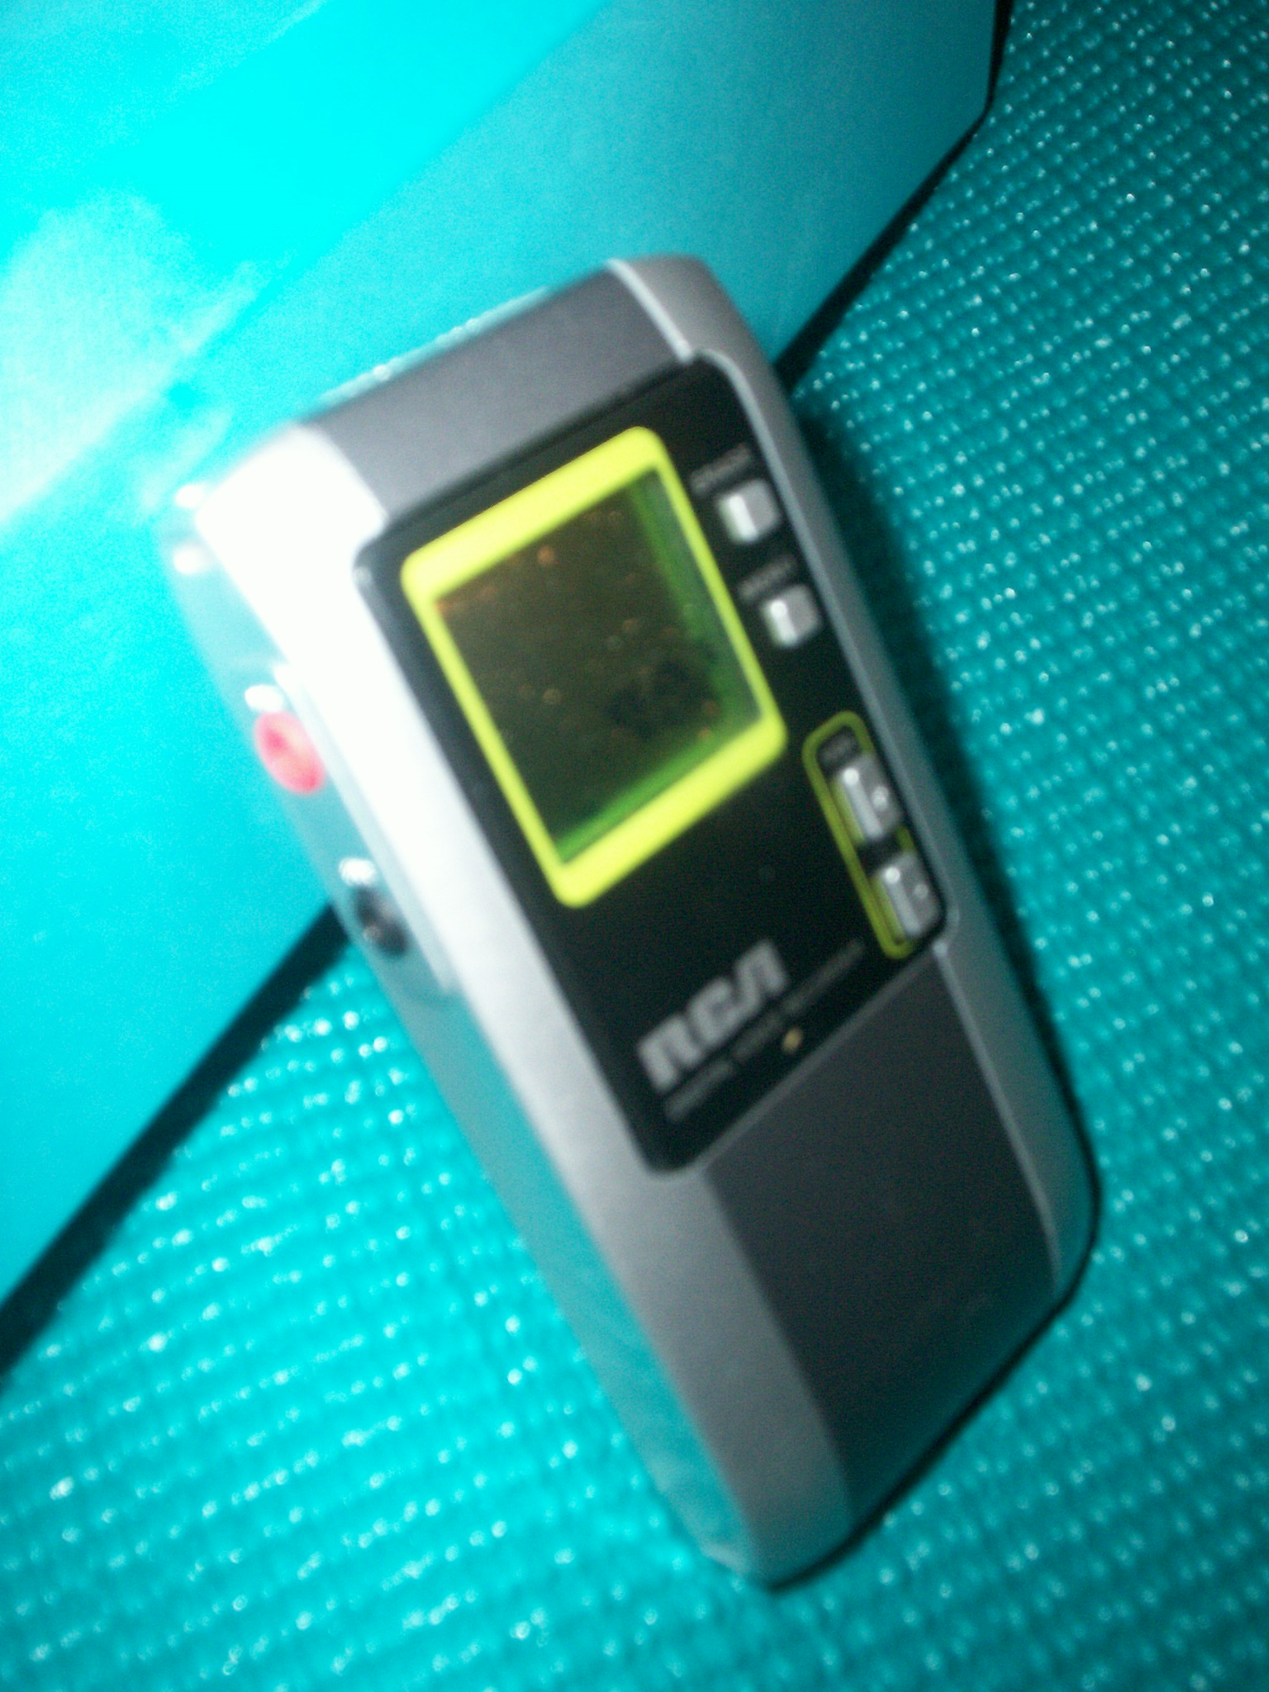
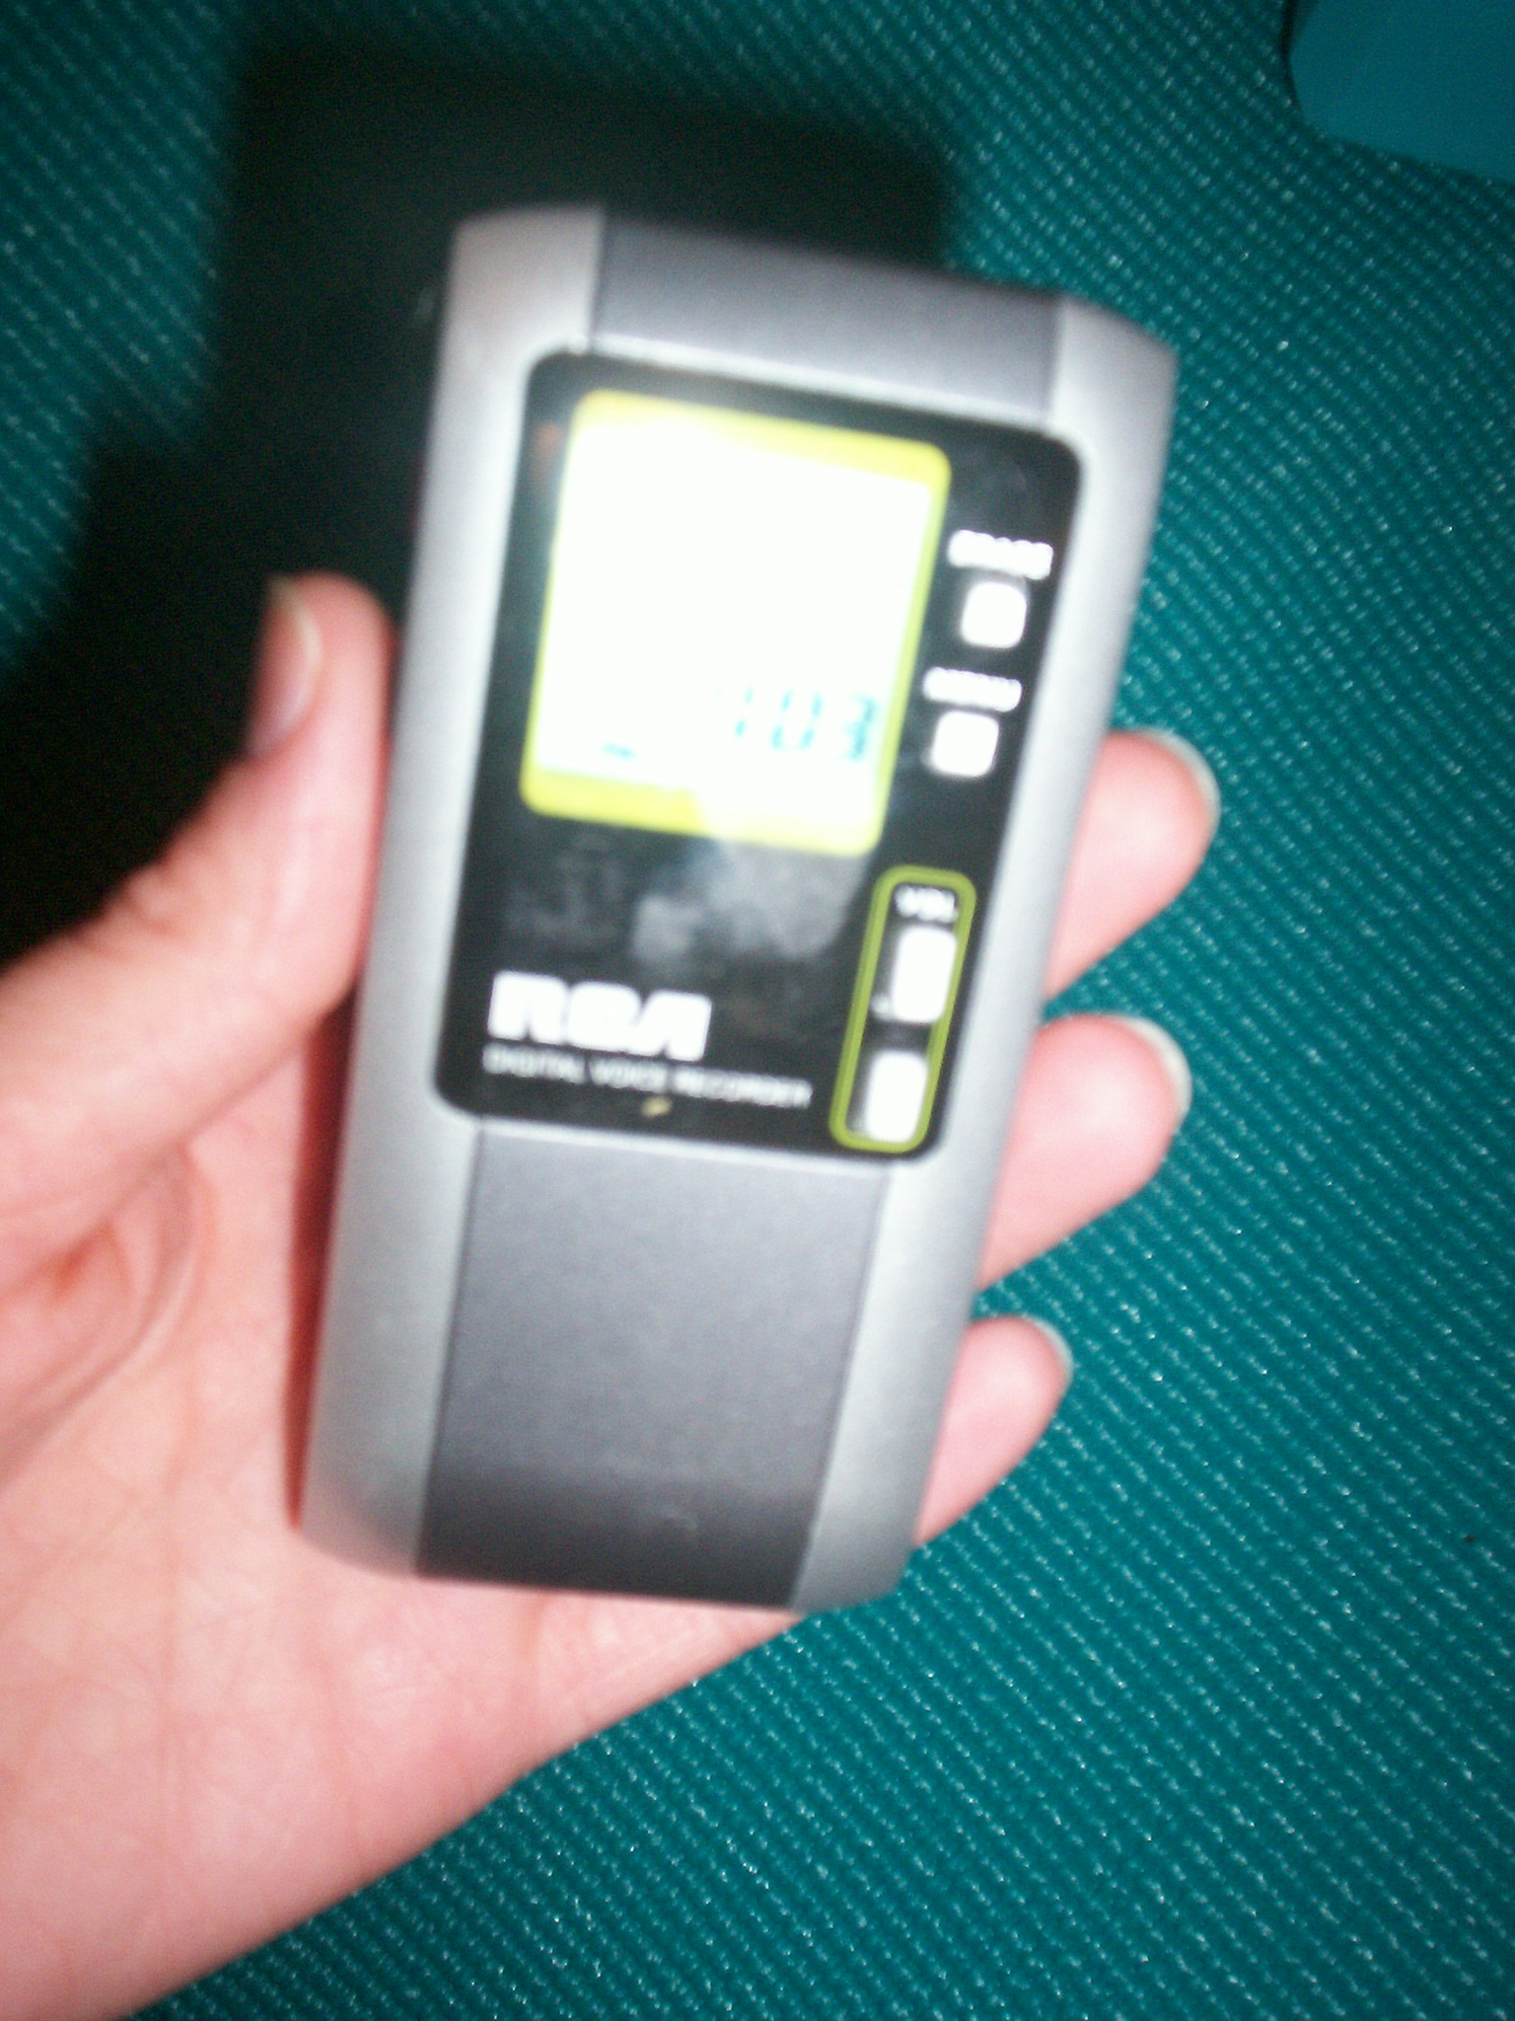
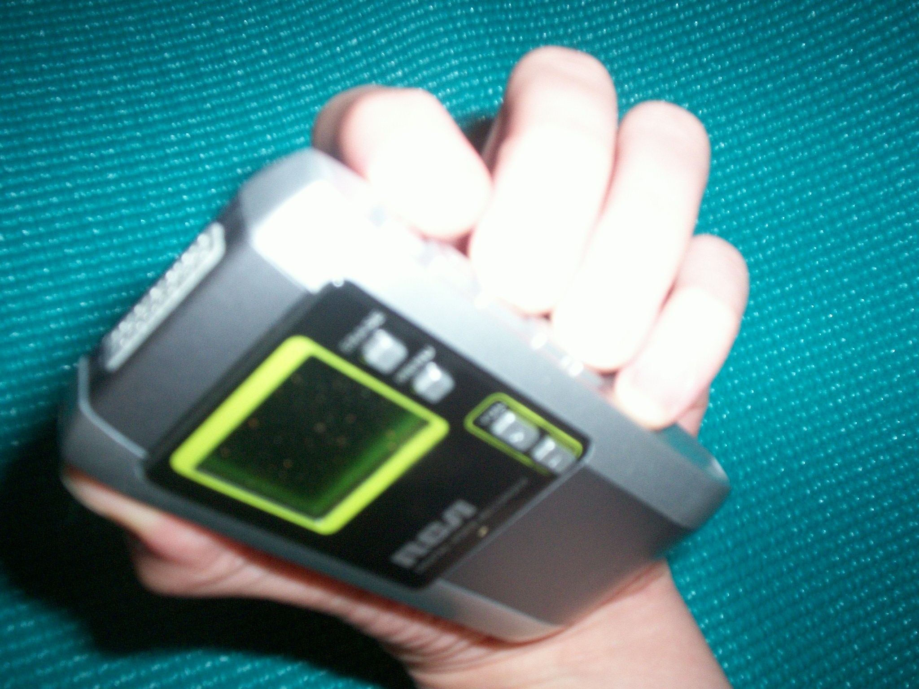
Lesson Plan Week 9, Day 2: How to Answer Questions & Introduction to Scoring
Summary: In this lesson, Jake will learn techniques for answering questions, a skill he will need for being a TA, for thesis defense, and in everyday life living in the US. We will go over different responses and practice how and when to use them. He can listen to his recorded questions and answers section (Q&A) and see how he could have responded differently. Towards the end of the lesson, I will introduce the AEOCPT rubric and scoring guideline, explain it, and answer any questions about it. I will use this rubric to score his presentations.
Goal: Improve Jake’s strategy for answering questions, ideally giving him more confidence and making him feel more relaxed for his next Q&A section. I want the ITA interview to be clear to him and understand why his presentations receive certain grades.
Prerequisite: Jake should have presented twice prior to this lesson.
Materials & Tools: Audio recorder with previously recorded questions and answers sections. Worksheet of answering question techniques. AEOCPT grading rubric.
Timeline:
0-10min: Explain and give examples of question answering techniques
10-20min: Discuss when to use certain techniques and practice using them
20-45min: Review previous Q&A sessions and apply answering techniques for improvements
45-55min: Introduce ITA interview rubric and score presentations
55-60min: Discuss next week, including preparation
Next Class Preparation: Prepare presentation for substitute tutor.

AEOCPT 3 Part Grading Rubric
A.) Pronunciation
0 Speaker is often not easily comprehensible due to one or a combination of the following: Consistent phonemic differences; Consistent inappropriate pitch falls or rises, or lack of pitch differentiation in thought groups; Consistent inappropriate pattern of stresses and unstressed syllables at the word and/or sentence level. Little to no evidence of monitoring. Requires significant and consistent negotiation by listener.

1 Speaker is occasionally not easily comprehensible due to one or a combination of the following: Consistent phonemic differences, especially for key words; Consistent inappropriate pitch falls or rises, or lack of pitch differentiation in thought groups; Consistent inappropriate pattern of stresses and unstressed syllables at the word and/or sentence level, especially key phrases. Little to no evidence of monitoring. Requires consistent negotiation by listener, especially if key words are not comprehensible.

2 Speaker is occasionally not comprehensible due to one or a combination of the following: Some consistent phonemic differences; Some consistent inappropriate pitch falls or rises, or lack of pitch differentiation in thought groups; some inappropriate pattern of stresses and unstressed syllables at the word and/or sentence level. Requires some negotiation by listener, especially at key phrases/words.

3 The speaker is comprehensible even though there may be some consistent phonemic differences, and/or some consistent inappropriate pitch falls or rises, or lack of pitch differentiation in thought groups, and/or some inappropriate pattern of stresses and unstressed syllables at the word and/or sentence level. Negotiation required by listener is minimal.

B.) Fluency
0 Speaker is often not easily comprehensible due to one or a combination of the following: numerous pauses and/or inappropriate pauses within thought groups; overuse of fillers; slow and strained speaking. Requires significant and consistent negotiation by listener.

1 Speaker is occasionally not easily comprehensible due to one or a combination of the following: numerous pauses and/or inappropriate pauses within thought groups; overuse of fillers; slow and hesitant but for routine lexical phrases. Requires consistent negotiation by listener.

2 Speaker is occasionally not comprehensible due to one or a combination of the following: some pauses and/or inappropriate pauses within thought groups; some distracting use of fillers; choppy. Requires some negotiation by listener.

3 The speaker is comprehensible even though there may be some occasional pauses and fillers. Generally smooth. Negotiation required by listener is minimal.

C.) Comprehensibility
0 Speaker is often not easily comprehensible due to one or a combination of the following: limited grasp of vocabulary. Speaker uses inappropriate vocabulary to accomplish task, simple vocabulary or repetition or circumlocution frequently; lack of grammatical control or use of very simple and/or repetitive grammatical structures. Frequent global and/or local errors. Requires consistent and significant negotiation.

1 Speaker is occasionally not easily comprehensible due to one or a combination of the following: inappropriate vocabulary to accomplish task, simple vocabulary, or repetition or circumlocution; lack of grammatical control, global and/or local errors; complex grammatical structures not used or misused. Requires consistent negotiation, especially at key words.

2 Speaker is occasionally not comprehensible due to one or a combination of the following: some inappropriate vocabulary to accomplish task, circumlocution, or redundancy; occasional errors in choice of vocabulary items. May evidence some ability to paraphrase. Requires some negotiation on part of listener, and listener may impose meaning at times. May show evidence of monitoring.

3 The speaker is comprehensible even though there may be some local errors in grammar. Speaker uses generally appropriate and extensive vocabulary to accomplish task successfully. Uses varied and complex grammatical structures. ay show evidence of monitoring. May evidence ability to paraphrase. Requires minimal negotiation by listener.

Answering Questions Techniques (adapted from http://useit.vn)
To prepare for the question-and-answer session after a presentation, anticipate questions in advance (what's the toughest question someone could ask?) and practice answering these questions. Consider the following tips for "remaining cool under fire":
• Repeat the question. You are responsible for communicating with the entire audience, not just the questioner. Repeat the question so that everyone understands it; this technique also gives you more time to phrase your reply.
• Clarify confusing or complicated questions. Be sure you understand the question. If you are in doubt, rephrase it and ask the questioner if that is the question.
• Watch out for multiple questions. Questioners often ask more than one question, and presenters often blunder when they try to answer two or three questions in one response. Let the audience know which question you are answering, and tackle the questions one at a time.
• Don't be forced into "yes or no" answers. Watch out for loaded questions. Take time to carefully phrase your answer.
• Don't be tricked by multiple choices. Questioners often pose choices between alternatives (for example, "a" or "b" . It is perfectly appropriate to answer "c" and explain why "a" or "b" is not the best choice.
• Answer the question completely. If you are not sure you have completely or exactly answered the question, ask the questioner if the answer was satisfactory. If a complete answer would require more time than is available, offer to discuss the subject after the session.
• Treat every question seriously. Never dismiss any question, even if you have covered the subject in your presentation. Don't put the questioner on the defensive; you will lose credibility with the audience.
• Keep your answers brief.
• Don't be drawn into debates.
• Keep your message intact. Be sure that the question-and-answer session reinforces your message. Find an opportunity to reiterate your message before you close the session.
1. Ways to delay answering a question while you think for a moment or check on your facts:
Well, let me see ...
Well now ...
Oh, let me think for a moment ...
I’m not sure, I’ll just have to find out ...
That’s a very interesting question ...
2. You may want to avoid answering altogether. Try using expressions like these:
I can’t answer that one, but I’ll tell you where you can find out.
I’m sorry. I prefer not to answer that question.
3. Paraphrasing
So what you’re saying is ...
In other words ...
So you mean ...
So, if I understand you correctly ...
4. Summarizing
To sum up then ...
So, to summarize what has been said so far ...
Lesson Plan Week 10, Day 1: Presentation For Real for Substitute
Summary: This will be Jake’s third presentation. By this time, he should be comfortable with the information he is presenting and the order of his presentation. This lesson will give him a chance to apply everything he has learned so far about presenting, audience, speaking, listening, and answering questions.
Goal: Jake will feel relaxed and confident in front of a new audience. He should have improved his presentation from listening strategies and Q&A section from the question techniques.
Prerequisite: Jake should have done two presentations prior to this lesson. He should know listening strategies and question answering techniques.
Materials & Tools: Audio recorder.
(Rough) Timeline:
0-10min: Introductions and set-up
10-35min: Presentation
35-50min: Q&A session
50-60min: Wrap-up and discuss next class
Next Class Preparation: Nothing to prepare for next class; will listen to and discuss presentation.

Lesson Plan Week 10, Day 2: Review with Substitute
Summary: This lesson gives Jake a chance to hear a different opinion other than mine about where he needs to improve and where he excels. Jake will listen to his presentation and critique and find areas of improvement along with his Q&A section. The substitute will follow along and do the same, and afterwards compare thoughts.
Goal: A new perspective will give him new areas and ideas for improvement. He should have a new light cast on his abilities and feel confident presenting in front of new people and answering unexpected questions.
Prerequisite: Jake should have given his third presentation by this time and gone through the Q&A session with someone other than myself.
Materials & Tools: Audio recording of last lesson’s presentation and Q&A session.
Timeline:
0-5min: Explain lesson plan and goal
5-45min: Listen to recorded presentation and self-evaluate
45-55min: Substitute should give feedback and compare areas of improvement with Jake
55-60min: Discuss what to expect for next week
Next Class Preparation: Be prepared to look at all three presentations and look at improvement over time. Jake should be prepared to answer what he has learned over this period of time and how he feels about his present performance skill.

Lesson Plan Week 11, Day 1: Reflection of Part 2 of Course
Summary: This is mostly a review lesson. We will discuss how he felt about last week and what he covered. I want to discuss how he feels about his presentations skills, responding to questions, self-evaluating skills, and general listening and speaking skills. I want to know how confident he is about presenting in front of new people and about answering questions on the spot. I want to know how he feels about the progress he’s made and any frustrations he may have. I will listen, critique, and score his new presentation so that he will have multiple feedback.
Goal: His metalinguistic knowledge has improved and he is able to self-evaluate. He should feel comfortable evaluating himself and feel confident that he doesn’t need someone to critique for him. I want him to see his improvement and change over the three presentations and realize his feelings about this. He should feel more confident in himself as a professional because of his improved language skills.
Prerequisite: Jake must have presented to someone other than myself and received feedback.
Materials & Tools: Audio recorder with third presentation and Q&A session.
Timeline:
0-25min: Reflection
25-60min: Listen to, discuss, and grade presentation
Next Class Preparation: Nothing to prepare. Next class will be an introduction to Part 3 of the course.
Lesson Plan Week 11, Day 2: Introduction to Part 3 of Course
Summary: This lesson will be a well deserved break from our typical work. We should meet at a restaurant to have a relaxed atmosphere. This will also give Jake a chance to apply his oral language skills and question answering techniques to a different and authentic context than academia. This entire lesson will be a time for him to ask any questions and for us to discuss the upcoming course schedule, to see if anything should be changed or added. As of now, Jake doesn’t know how the AEOCPT process works and doesn’t know what to expect. I will go over the general process, tell him what to expect, and what will happen afterwards. I will go over test result consequences and what happens post-test.
Goal: He should feel involved in the planning process of the course. I want to remind him that this course is directed at his needs, and I want him to feel comfortable offering suggestions or changes for the next part of the course. After this lesson he should understand the expectations of the AEOCPT.
Prerequisite: We are finished with Part 2 of the course and are ready to move on to Part 3.
Materials & Tools: Outline of IPA interview process.
Timeline:
0-20min: Order food and discuss whether anything should be changed
20-60min: Share and discuss IPA interview process
Next Class Preparation: There is nothing to prepare outside of the course. We will discuss and practice the first skill measured in the AEOCPT.
American English Oral Communicative Proficiency Test (adapted from Dr. Karen Johnson’s AEOCPT power point)

AEOCPT
- 20-minute face-to-face interview between one international teaching assistant (ITA) and two trained evaluators from the Department of Applied Linguistics.
- 4 sections:
  - explain a common term in your field
  - participate in a role-play
  - state your opinion on topics of general interest
  - present an announcement to a group of students

AEOCPT Evaluation
- Raters evaluate
  - pronunciation
  - fluency
  - overall comprehensibility
- Scores range from 0-300.
  - 250 or higher allows an international student to assume teaching responsibilities with no restrictions.
  - under 250 require additional coursework in English

AEOCPT Placements
- 250-300 None
Student may assume teaching duties with no restrictions.
- 230-249 Enroll in ESL 118G
After one semester, student should be able to assume teaching duties with no restrictions. Students enrolled in ESL 118G must receive a grade of "A" before they assume teaching duties with no restrictions.
- 200-229 Enroll in ESL 117G
Will require at least two semesters before student is recommended to teach. Students enrolled in ESL 117G must receive a grade of "A" before they will be allowed to enroll in ESL 118G.
- below 200 Enroll in ESL 115G
Will require at least three semesters before student is recommended to teach. Students enrolled in ESL 115G must receive a grade of "A" before they will be allowed to enroll in ESL 117G.

Post Evaluation
- Evaluates ITA’s overall comprehensibility and communicative effectiveness.
- a 30-minute examination in which ITAs
  - answer an open-ended question,
  - participate in a 3-5 minute role-play in which an instructional problem or dilemma must be resolved,
  - give a 10-minute teaching simulation of a concept in the ITA’s field of study.

- Two trained raters from LALS assess pronunciation, fluency, and overall comprehensibility.
- A department representative and an undergraduate student are invited to attend and provide a general assessment of the ITA’s communicative effectiveness.

