Running Head: FINAL PAPER

Final Paper
Sarah Pun
APLNG 410
12/16/2009

Final Paper
Introduction
This paper combines several previous research done on one particular individual . My language student is learning English in the US; his name is Jake Cho and he is from Korea. I first interviewed him in a Learner Profile to get to know his language background and goals, as well as cultural and political background. Next, I performed a series of tests in a Diagnostic Analysis to find trouble areas and patterns. The next step was to create a Lesson Plan for my learner, focusing on one pattern found in the analysis. I agree with the belief that “students must first be able to recognize that they are making mistakes before they can correct them” and follow this ideology in my lesson, along with focusing on self-monitoring (Celce-Murcia, et al., 1996, pp.348-349). I will attempt to evaluate the success of this lesson plan and identify areas that can be made better in the future.
Many factors determine how a person learns a language, why they learn it, and how fluent they become. Many of these factors depend on a person’s identity which is shaped from their culture. Their country’s history and political background will be a major factor in this decision as well as the culture they are socialized into. Learning the history, political background, and cultural background of students can benefit language teachers immensely. I attempted to create a picture of Jake in the Learner Profile by exploring his educational background, cultural background, and motivation for learning English.
I have been working with Jake for nearly a year. He is from the great city of Seoul in Korea—born and raised. His first language is Korean and besides English, he has never studied another language. He is 28 years old and has been in the US since last fall; a little over a year. He is a graduate student at Penn State University working towards his Master’s Degree in Civil Engineering. Since moving to the US, he has had a crash course in the English language.
Although Jake studied and learned English when he was young, he was never prepared for the English he would need while living in the US. He started learning English in middle school at the age of 15. He studied English in a formal setting from the age 15 until his first semester in college when he was 22 years old. According to Jake, Korea’s language teaching methodology is much like the Grammar Translation method; his schools focused on reading and writing and never on oral language. He began studying English again when he was 26 years old and had decided to move to the US. In order to get into the Civil Engineering graduate program, he needed to pass the GRE and TOEFL. He studied on his own for these exams, but did not study spoken English because he was not tested on oral proficiency. “They never teach me the speaking, just reading. So when I move here, I almost can’t speak English.” Luckily, his first semester here last fall, he took an ESL course on presentation skills: “My English skills so bad that this course was hard for me actually.” Wanting to rapidly improve his English listening and speaking skills, he hired me to be his tutor; we have met from then until now regularly, 2 hours a week.
In an attempt to explore socio-political issues, I asked Jake to explain how he feels English is viewed in Korea. According to him, all Koreas have a desire to learn English—including listening and speaking—but their education system does not meet their needs. Employers want to hire Koreans fluent in English, especially businesses. There is a standardized exam which tests English reading and writing skills that all interviewees must take; employers place a great deal of importance on this exam score. Interviewees are also tested on their oral English proficiency during interviews.
Interestingly enough, there does not seem to be a preferred variety of English in Korea. Korean people generally have a goal of being able to communicate with foreigners in their country; intelligibility is their goal. He says that it does not matter to them which variety they speak, they are not trying to learn American pronunciation over British pronunciation for example, they simply want to be understood. Jennifer Jenkins (2002) points out that pronunciation is directly related to identity. Dalton and Seidlhofer (1994) argue that insisting on learners to conform to target-language pronunciation may been seen as “forcing them to reject their own identity” (as cited in Jenkins, 2002, p. 16). It is vital to know a learner’s pronunciation goal to prevent comprimsing their identity. This cultural and identity knowledge influences both his motivation to learn English and how and what I teach him.
After learning his culture’s view on learning and speaking English, I wanted to know his personal reasons and motivation for learning English and also his language goals. Jake moved to the US like so many others do: to learn English and to increase his chances of success and being able to live a good life. He wants to get a job in the US with a company and become a valuable member of that company; a goal he doesn’t believe possible without English fluency. Continuing his education to earn a PhD is also a possibility while Jake lives in the US. He wants to stay in the US and bring his family here; he wants to be able to help and support his family.
Because he wants to stay in the US, rather than go back to Korea after he graduates, being fluent in English is his highest priority. He wants to be able to easily communicate with natives (and he stresses easily) and to be able to speak English without thinking. He wants to be able to think in English instead of thinking first in Korean, and then translating everything to English in his head: “I want to be able to speak English without thinking, but it is very hard actually, right?” Although he wants to increase his fluency, he does not have any goals like, “I want to speak like a native English speaker. He wants people to be able to understand him and as long as they can understand him, it does not matter if he pronouncing things differently or has minor grammatical errors. Jenkins (2000) uses the term intelligibility as the first level, or basic level, of understanding between the speaker and listener. Jenkins acknowledges that some level of recognizability and recognition of form is necessary for communication and that with a “set of unifying features…pronunciation will not impede successful communication” (2000, p. 95). I believe it is this intelligibility that Jake is striving for.
Because I have been working with Jake for a little more than six months, I already know that he is extremely motivated to learn English, very hard-working and has a great, positive attitude towards becoming fluent in English. Because of his cultural background, he is not interested in speaking like me, a so-called “native English speaker.” He believes it is important to be fluent in English and that this will enhance his life and career. In my attempt to create a picture of my student, I explored his education and cultural background as well as his motivation for learning English. The factors, among many others, shape his reasons for learning English, and how fluent he will become. It is important for me, as a language teacher, to understand these factors so that my teaching reflects Jake’s expectations and goals for himself.
Analyze
I met with Jake Wednesday, October 28, 2009, and did a series of diagnostic tests. There were three tests total, each testing a different register of speech, and all were recorded by me on my handheld digital voice recorder. The first one tested his citation speech by having him read aloud list of words taken from Avery and Ehrlich’s Teaching American English Pronunciation (p. 183). The next test centered on formal register: he read, “Diagnostic Test: Segmentals & Suprasegmentals,” a handout I received in class adapted from Prator and Robinett’s Manual of American English Pronunciation. For the last test, I asked him two questions with the attempt to focus on casual speech. I asked him to tell me about a time when he was in danger of death, and after that, to tell me about the rudest person he has ever met.
In these three tests, I noticed many different problems and many reoccurring problems. Reoccurring problems indicate errors that need to be corrected; therefore, I felt that these problems were important to examine and look into depth. The first problem considered is situations where /r/ is avoided. Jake seemed to avoid the /r/ in /ər/ in words like “learn” and “theater,” and the /r/ in /or/ in words like “more” and “informal.” He has told me many times that the American /r/ is the most difficult sound for him to produce. Another reoccurring problem I noticed was the change of lax vowel /ɪ/ to tense vowel /iy/. This occurred many times in words like “practice” and “this.” However, in accordance with the recorded data, he did not have trouble distinguishing any other lax and tense vowels, so there seems to be a problem with place of articulation in addition to tenseness.
Jake also seemed to have trouble with the semi-vowel /w/. In most cases I observed, Jake omitted the /w/ sound where it usually occurred, like in “language” and “quickly.” Although Jake can pronounce the /θ/ (theta) sound with no trouble, he cannot seem to pronounce the /ð/ (eth) sound. In the words “that” and “though,” he replaces the /ð/ with the /d/ sound. In words like “think,” he has no trouble with the pronunciation; these are both interdental fricatives. The theta is voiceless whereas the eth is voiced, so the problem appears to be in voicing. He generally replaces the eth with the /d/ sound, which is voiced, so although the problem seems to be a difference in voicing, it may actually stem from place of articulation. He can pronounce an interdental fricative, but it appears to be easier to pronounce a voiced alveolar stop than a voiced interdental fricative.
My conclusions in my analysis are fairly vague because many of the problems I noticed were not reoccurring. Some problems occurred more than others, but it seems that I do not have enough data to discover a solid pattern. I feel that the more reoccurring problems, like trouble with /r/, /w/, /ð/, /ɪ/ are worth correcting to meet the goals of my learner. Because his goal is not to sound like a “native” English speaker, and because he is not trying to change his Korean accent, it is more necessary to focus on problems that impede intelligibility like /r/ and /w/. Using /d/ rather than the eth and /iy/ rather than /ɪ/ do not interfere with my ability to understand him as much as the other sounds do.
Lesson
I chose to focus on the /r/ sound in /ər/ and /or/ for my lesson plan because I felt that this was the sound impeding the most with Jake’s intelligibility. I began the lesson by explaining to my student why we were focusing on this sound (referring to the Learner Profile and Diagnostic Analysis). The first activity we did was with Sammy Diagrams (see below); with it we discussed tongue placement in relation to /r/ sound and vowels. The rest of the lesson focused on a list of minimal pairs and trouble words from the diagnostic (see below). We not only worked on pronunciation and tongue placement for the words on the list, but we also focused on self-monitoring.
I have been working with Jake for about a year and have noticed that he is weak in self-monitoring. The lesson focused on the skill of self-monitoring towards the end with the help of my audio recorder. For the assessment of the lesson plan, I looked at Jake’s self-monitoring: is he able to correctly identify problem words and then effectively correct his pronunciation due to learning about tongue positioning? Here is an excerpt of the Lesson Plan followed by an evaluation of the lesson.
Lesson Plan Excerpt
I. Introduce topic /ər/ (5min.)
A. Why are we focusing on this? Explain results of Diagnostic Analysis and why it’s important to focus on this sound in accordance to the Learner Profile.
II. Sammy Diagram Activity (10-15min.)
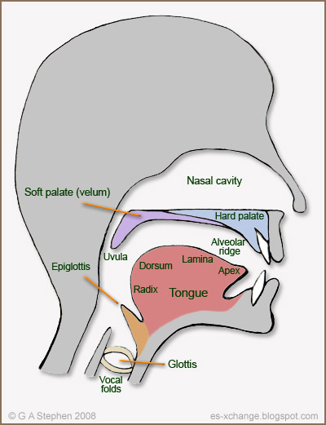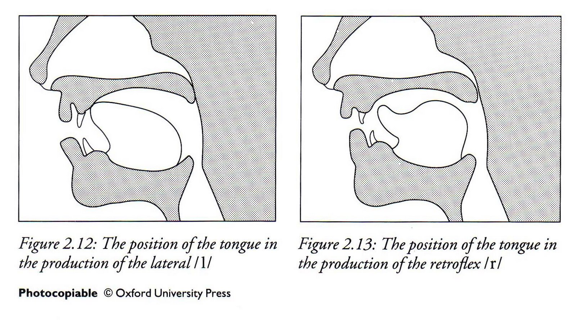
A. Use these diagrams to explain American /r/ tongue position.
B. Have student practice making the /ər/ and /or/ sounds in isolation. Talk about the differences in tongue and mouth position between the two sounds.
III. Word List Activity (20-25min.)
burr bore Learn girl bored bird roar choir her Ford Door turn
purr pour teacher more informal Doctor other number brother
fur for Theater purple or shore mermaid yearn morbid nor circle

A. Read the list two times to student. First time normal speed, second time slowly with emphasis on /or/ and /ər/ sounds.
B. Read a word, then have student repeat…when there is trouble, focus on tongue position. Repeat this as many times as necessary, speeding up each time.
C. Have student produce sounds alone, stopping him and spending time on trouble spots, focusing on tongue position. Repeat as many times as necessary, speeding up each time.
IV. Self-monitoring (20-25min.)
A. Have the student read the list of words into the digital recorder without stopping him.
B. Student will listen to himself as many times as necessary, determine problem words (circle or write them down), and attempt to explain why these problems are occurring (using the Sammy Diagram in reference to tongue position and place of articulation).
C. Student will then attempt to correct the problem words, recording them into the digital recorder.
D. Student should listen to the recording again and evaluate his pronunciation and progress. Keep trying to listen and correct the problem words.
Evaluation
I think it was valuable explaining to Jake why we were focusing on the avoidance of the /r/ sound at the beginning of the lesson. He is an advanced adult learner of English, so is able to comprehend this metalanguage and since I already showed and explained the Learner Profile and Diagnostic Analysis in previous meetings, it was useful to build off his prior knowledge. I showed him how I was focusing on his goals by choosing to focus on /r/, which created a mutual understanding between us and motivated him to try his best during the lesson.
I would not change the next part of the lesson plan either: Sammy Diagram and parts of the mouth. I taught him a few places of articulation, focusing on the palate, alveolar ridge, and glottis so that I would have the language to explain tongue placement. We talked about the places of the mouth, practiced making sounds that utilized these areas, like /h/ for glottis, and then focused on how this related to the /r/ sound. We tried producing /ər/ and /or/ in isolation, feeling the differences in tongue placement and airflow. He seemed to be following along, asking questions when he had them, and actively participating. He said that this was information he had never learned before and was useful to know what position his tongue should be in, rather than just placing it randomly, or not paying any attention to it.
I felt that the beginning of the lesson was successful, however, there were many things in the later part that could have been better. In the Word List Activity in the Lesson Plan, I first read the list at normal speed and again stressing the /ər/ and /or/ sounds. I do not think that it was effective for me to read the words out loud, least not two times. It would have been more effective to have Jake read them out loud with me, rather than listen, or perhaps skip to the next part of the activity, which was to have him say a word after I said it. It may not have been effective for me to read the words out loud alone because the words are fairly simple, short words. He spent a lot of time pronouncing the words before we started any recording, which I think was useful for him to focus on his tongue placement.
One problem that arose which I had not predicted had to do with the spelling of the words on the list. Jake often pronounced words as they are spelled, rather than how they should sound. It was helpful for him when I rewrote the word in a more phonetic way: for example, writing “yearn” as “yern” or “doctor” as “docter.” It may be helpful next time to write a word list using IPA symbols rather than conventional spelling because I think focusing on tongue placement while trying to remember pronunciation versus spelling differences was too much to focus on at once. I did not want spelling to be a focus in this lesson, but unfortunately, it interfered.
I next had Jake read the list by himself, without me reading it first, attempting to read it quickly. I think this activity was not effective because his self-monitoring ability is very weak. I do not think it was useful for him to read and for me to stop and correct him where he needed me to. He should be stopping himself and identifying his problems, not relying on me to do this. This activity was good practice, but could have been much more effective if I would have recorded him and then went over the recording with him, listening to it together and correcting it together with him.
Moving on to the self-monitoring section of the lesson, I first had Jake record himself reading the list without any interruptions from me. He did this and then listened to it, but the result was unsuccessful: he could not identify any trouble areas. He told me that he could not tell what words he was mispronouncing. I improvised and decided that it might help him to first hear me pronouncing the word, then listen to himself and compare the difference. We tried again with the recorder, this time me reading a word, him following suit, and going back and forth like this until we read all the words. Then, I had him listen to the recording and identify the words he mispronounced. This time, the listening activity was successful and he identified exactly the same problem words that I did. I next wanted to focus on these trouble words, so we recorded only the trouble words, using the same method as before (me reading first and him following).
Using this new recording, we discussed why he was having problems with these words in particular. The discussion focused on tongue placement and place of articulation, relating back to what we learned at the beginning of this lesson and the Sammy Diagram. We noticed that front vowels and the /l/ sound frequently created problems with his /r/ sound, making it difficult to produce. We also talked about what area in the mouth the sound was created. Another problem we noticed was a lack of prediction of sounds; sometimes he could produce one word in a minimal pair perfectly, but had trouble with the other word because his tongue was not prepared to pronounce the /r/ sound. When I told him to think about the /r/ sound before he started to pronounce the word, he was able to produce it perfectly. This discussion lasted approximately fifteen minutes and was an unexpected part of the lesson. For me, it was almost another Diagnostic and helped me figure out why he can pronounce /ər/ or /or/ in some situations, but not in others.
Overall, I think the lesson was effective and successful, however, the success may not be long-term. The discussion at the beginning, using the diagrams and talking about tongue placement, was new and necessary information for Jake. I think this information will stay with him because I only focused on three areas of articulation and kept it very simple. Recording me reading the list with him following was helpful for him to self-monitor. Self-monitoring on his own was not successful, but I think he just needs more time to train his ear. For now, he will need assistance like I provided to be able to self-monitor. I think the discussion at the end about why he had trouble with certain words was also beneficial for him, but may be too abstract to apply immediately. Thinking about a word before he pronounced it was helpful for a better pronunciation, but may not be realistic in conversation as there is little time to think and he may not focus on producing /r/ sound with me telling him to.
Conclusions
I found that it is most important in teaching to build off things that the learner knows or that I have already taught (scaffolding). Although the lesson may not have long-term effects, it will if I keep building on it. Jake was not able to self-monitor without help from me, but if we continue to practice this skill and I help less each time, he will eventually be able to do it on his own. Taking these building steps will give him time to train his ear to listen more closely to the sounds he is producing or is not producing. Jake was able to produce all the trouble sounds in the end, but needed to first learn about tongue placement and needed time to think about the sound before producing it. There will need to be more practicing and building off this lesson in order to achieve long-term results. If he keeps practicing the sounds, he will need less time to think about the word, and eventually will be able to produce the sound correctly automatically.
I was able to keep my learner motivated by teaching a sound he needed to correct to meet his own goals. Without doing a Diagnostic Analysis, I may have been teaching from a list of common errors Koreans make (see Avery & Ehrlich); this is a problem because some errors on the list may not be a problem for Jake, whereas some errors he does make may not be on the list. Without doing a Learner Profile, I would not have known Jake’s cultural background and learning goals and expectations. The Learner Profile was vital for allowing me to understand the thinking behind Jake’s expectations. It is extremely useful to know his learning goals so that I may teach things that he wants to learn. In future sessions with Jake, I will continue to base my lessons around his learning goals and give him time and scaffolding to learn the objective of the lesson.

References
Avery, P. & Ehrlich, S. (1992). Teaching American English pronunciation. Oxford: Oxford University Press.
Celce-Murcia, M., Brinton, D.M., & Goodwin, J.M. (1996). Teaching pronunciation: A reference for teachers of English to speakers of other languages. Cambridge: Cambridge University Press.
Jenkins, J. (2000). The phonology of English as an international language: New models, new norms, new goals. Oxford: Oxford University Press.

